# Create Users Table (for authentication and role management)

CREATE TABLE Users (

UserId INT PRIMARY KEY AUTO_INCREMENT, -- Auto-incrementing primary key

Email VARCHAR(100) NOT NULL UNIQUE, -- User's Email (unique)

PasswordHash VARCHAR(255) NOT NULL, -- Hashed password

Role VARCHAR(50) NOT NULL, -- User role (e.g., 'Chef' or 'Admin')

CreatedAt DATETIME NOT NULL DEFAULT CURRENT_TIMESTAMP, -- Creation timestamp

UpdatedAt DATETIME NOT NULL DEFAULT CURRENT_TIMESTAMP ON UPDATE CURRENT_TIMESTAMP -- Update timestamp

);

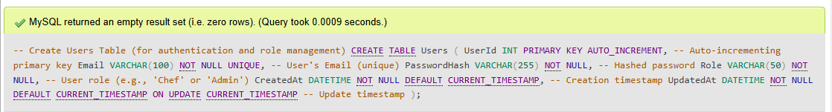

# Create ChefProfiles Table (stores detailed chef information)

CREATE TABLE ChefProfiles (

ProfileId INT PRIMARY KEY AUTO_INCREMENT, -- Auto-incrementing primary key

UserId INT NOT NULL, -- Foreign key to Users table

FullName VARCHAR(255), -- Full name of the chef

Bio TEXT, -- Short biography

ProfilePicture VARCHAR(255), -- Path or URL to profile picture

ContactDetails VARCHAR(500), -- Contact information

SocialMediaLinks TEXT, -- Social media links (JSON or comma-separated)

UpdatedAt DATETIME NOT NULL DEFAULT CURRENT_TIMESTAMP ON UPDATE CURRENT_TIMESTAMP, -- Timestamp for last update

FOREIGN KEY (UserId) REFERENCES Users(UserId) -- Foreign key constraint to Users

);

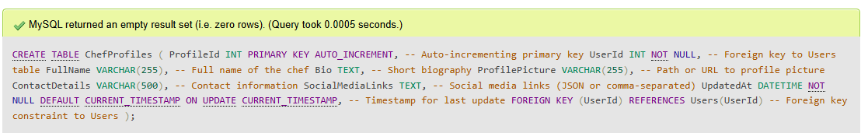

# Create Recipes Table (stores recipe information)

CREATE TABLE Recipes (

RecipeId INT PRIMARY KEY AUTO_INCREMENT, -- Auto-incrementing primary key

ChefId INT NOT NULL, -- Foreign key to Users table

Title VARCHAR(255), -- Recipe title

Description TEXT, -- Brief description of the recipe

Ingredients TEXT, -- Ingredients for the recipe

Instructions TEXT, -- Step-by-step instructions for the recipe

RecipeImage VARCHAR(255), -- Image URL or file path for the recipe

PublishedAt DATETIME NOT NULL DEFAULT CURRENT_TIMESTAMP, -- Publication date and time

UpdatedAt DATETIME NOT NULL DEFAULT CURRENT_TIMESTAMP ON UPDATE CURRENT_TIMESTAMP, -- Timestamp for last update

FOREIGN KEY (ChefId) REFERENCES Users(UserId) -- Foreign key constraint to Users

);

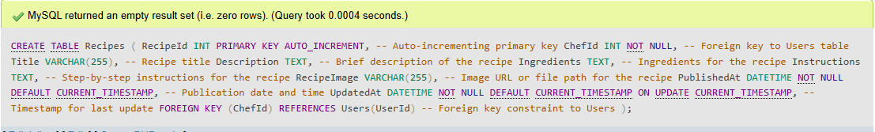

# 

# Create RecipeComments Table (for comments on recipes by users)

CREATE TABLE RecipeComments (

CommentId INT PRIMARY KEY AUTO_INCREMENT, -- Auto-incrementing primary key

RecipeId INT NOT NULL, -- Foreign key to Recipes table

UserId INT NOT NULL, -- Foreign key to Users table (the commenter)

CommentText TEXT, -- The comment text

CreatedAt DATETIME NOT NULL DEFAULT CURRENT_TIMESTAMP, -- Timestamp for comment creation

FOREIGN KEY (RecipeId) REFERENCES Recipes(RecipeId), -- Foreign key constraint to Recipes

FOREIGN KEY (UserId) REFERENCES Users(UserId) -- Foreign key constraint to Users

);

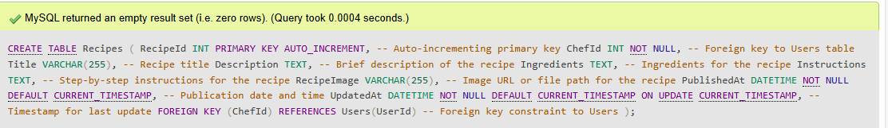

# Create RecipeShares Table (tracks social media shares of recipes)

CREATE TABLE RecipeShares (

ShareId INT PRIMARY KEY AUTO_INCREMENT, -- Auto-incrementing primary key

RecipeId INT NOT NULL, -- Foreign key to Recipes table

SocialMediaPlatform VARCHAR(100), -- Name of social media platform (e.g., 'Facebook')

ShareDate DATETIME NOT NULL DEFAULT CURRENT_TIMESTAMP, -- Date and time when recipe was shared

FOREIGN KEY (RecipeId) REFERENCES Recipes(RecipeId) -- Foreign key constraint to Recipes

);

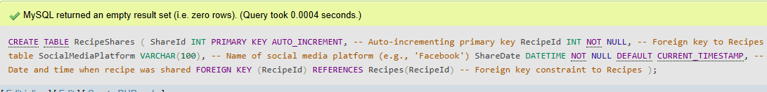

# TABLE RecipeComments

CREATE TABLE RecipeComments (

CommentId INT PRIMARY KEY AUTO_INCREMENT, -- Auto-incrementing primary key

RecipeId INT NOT NULL, -- Foreign key to Recipes table

UserId INT NOT NULL, -- Foreign key to Users table (the commenter)

CommentText TEXT, -- The comment text

CreatedAt DATETIME NOT NULL DEFAULT CURRENT_TIMESTAMP, -- Timestamp for comment creation

FOREIGN KEY (RecipeId) REFERENCES Recipes(RecipeId), -- Foreign key constraint to Recipes

FOREIGN KEY (UserId) REFERENCES Users(UserId) -- Foreign key constraint to Users

);

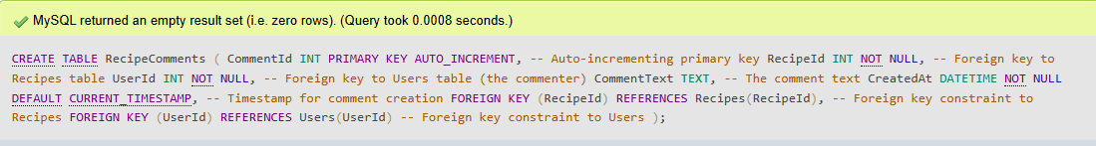

# 

# Add indexes to improve performance for frequent queries (e.g., searching recipes, users)

CREATE INDEX idx_recipes_title ON Recipes (Title); -- Index on Recipe Title for fast search

CREATE INDEX idx_recipe_comments ON RecipeComments (RecipeId); -- Index on RecipeId for faster comment queries

CREATE INDEX idx_recipe_shares ON RecipeShares (RecipeId); -- Index on RecipeId for faster social media share queries

